ERS paper:

<https://erj.ersjournals.com/content/54/suppl_63/PA5029>

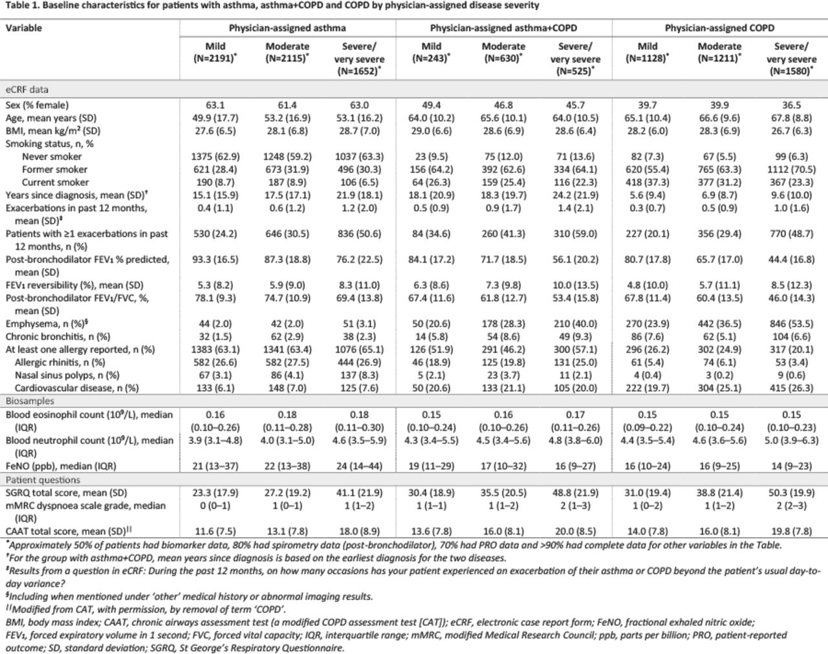

Definitions: <https://erj.ersjournals.com/content/56/suppl_64/2201?utm_source=TrendMD&utm_medium=cpc&utm_campaign=European_Respiratory_Journal_TrendMD_0>

Thorax Paper:

<https://thorax.bmj.com/content/58/1/37.full>

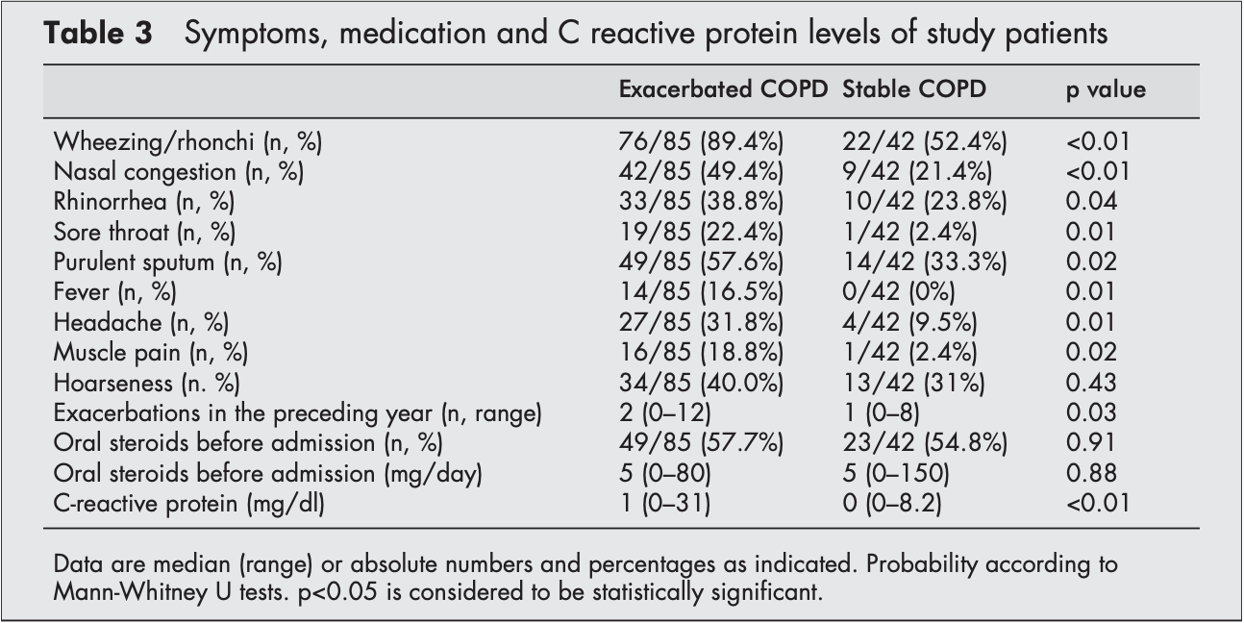

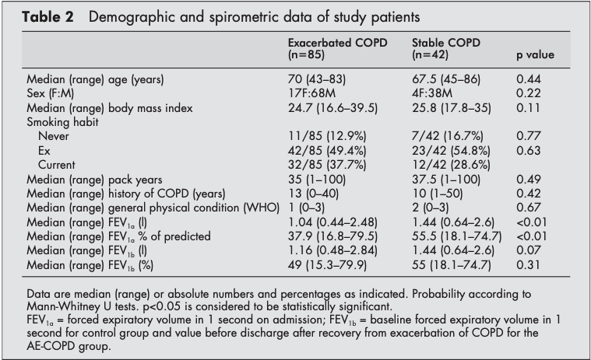

Definitions:

Exacerbation of COPD: condition according to the definition given above plus worsening in dyspnoea, cough and expectoration.

Stable COPD: condition according to the definition given above without exacerbation (defined above) in the 30 days before hospital admission and without changes in treatment within the last 14 days (including inhaled and oral medication).